

CYBERSTER
NetSec Internship - Week 5 Task Report
Enterprise-Level Network Architecture & Dynamic Routing
Intern Name: | Muhammad Raza
Instructor Name: | Muhammad Huzaifa Riaz
Company: | CYBERSTER (Batch 2)
Task: | Enterprise-Level Network Architecture & Dynamic Routing
Date: | 25 July 2026

Table of Contents

Section
1. Executive Summary | 3
2. Architectural Block Design | 3
2.1 Architecture Overview Table | 3
2.2 Network Topology | 4
3. Implementation: Configurations & Steps | 4
3.1 Device Placement & Cabling | 4
3.2 Dynamic Routing — OSPF | 5
3.3 Core-R1 Configuration | 5
3.4 Core-R2 Configuration | 6
3.5 Agg-R1 Configuration | 6
3.6 Dist-SW1 Configuration | 7
3.7 Dist-SW2 Configuration | 7
3.8 Wireless Access Point Configuration | 8
4. IP Addressing Scheme | 8
5. Connectivity Validation | 9
6. Conclusion | 9

1. Executive Summary
For Week 5, the objective was to design, deploy, and validate a full enterprise-level network architecture using Cisco Packet Tracer. The topology was required to strictly follow a modular block design, incorporating Core, Aggregation, Distribution, and Access blocks. Furthermore, the network had to support a diverse range of endpoint devices - wired PCs and laptops, wireless laptops, and smartphones - via Access Points, and rely entirely on dynamic routing (OSPF) to achieve end-to-end connectivity.

Requirement | How It Was Met
Modular block design | Four distinct blocks implemented: Core, Aggregation, Distribution, and Access, each with dedicated hardware.
Dynamic routing (no statics) | OSPF Area 0 deployed across all Core routers, Aggregation router, and Layer 3 Distribution switches.
Wired endpoint support | Wired PCs and Laptops connected via Cisco 2960 Access Switches in the Access Block.
Wireless endpoint support | Two Wireless Access Points configured with unique SSIDs (VLAN10-WIFI and VLAN20-WIFI) for wireless Laptops and Smartphone.
WAN/External connectivity | Cloud-PT emulation connected to Agg-R1 with a public IP subnet (203.0.113.0/24) to simulate an external WAN boundary.
End-to-end validation | Smartphone0 pinged external gateway 203.0.113.1 - 4/4 packets, 0% loss, 39ms average RTT.

2. Architectural Block Design
The network was segmented into four distinct functional blocks, allowing for scalability, fault isolation, and efficient traffic flow. Each block has a precisely defined role within the enterprise hierarchy.

2.1 Architecture Overview Table
Block | Devices | OSI Layer / Role | Function in This Lab
Core Block | Core-R1, Core-R2 (Cisco 2911) | Layer 3 - High-speed backbone routing | Ultra-fast packet switching between Aggregation and Distribution blocks. No policy overhead.
Aggregation Block | Agg-R1 (Cisco 2911), Cloud-PT | Layer 3 - External WAN/Cloud gateway | Boundary between internal enterprise and external WAN/Internet. Hosts public IP subnet 203.0.113.0/24.
Distribution Block | Dist-SW1, Dist-SW2 (Cisco 3560-24PS) | Layer 3 - Inter-VLAN routing + SVI gateway | Acts as the default gateway for all access-layer subnets. Performs ip routing, creates SVI gateways, and runs OSPF.
Access Block | Access-SW1/2/3 (2960), AP1, AP2, PC0, Laptop0/1/2, Smartphone0 | Layer 2 - Endpoint connectivity | Provides wired and wireless access to all end devices. Strictly Layer 2 - no routing performed here.

2.2 Network Topology
The complete enterprise topology is illustrated below with all four blocks visually delineated. Solid lines represent routed point-to-point links; dashed lines represent trunk links.

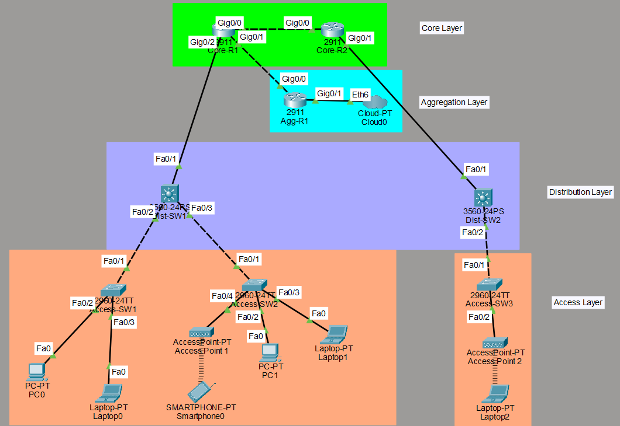
Figure 1: Complete enterprise topology - Core (green), Aggregation (cyan), Distribution (purple), and Access (orange) blocks.

3. Implementation: Configurations & Steps

3.1 Device Placement & Cabling
The physical topology was constructed top-down. The following cable types were used for each connection tier:

Connection | Cable Type | Reason
Core-R1 ↔ Core-R2 | Copper Cross-Over (Gigabit) | Router-to-router; same device type requires crossover
Core-R1/R2 ↔ Agg-R1 | Copper Cross-Over (Gigabit) | Router-to-router inter-block uplink
Core-R1 ↔ Dist-SW1 (Fa0/1) | Copper Straight-Through | Router-to-switch different device types
Core-R2 ↔ Dist-SW2 (Fa0/1) | Copper Straight-Through | Router-to-switch different device types
Dist-SW1/2 ↔ Access-SW1/2/3 | Copper Straight-Through | Switch-to-switch downlink to access tier
Access-SW2 ↔ AP1, SW3 ↔ AP2 | Copper Straight-Through | Switch-to-AP standard wired backhaul

3.2 Dynamic Routing - OSPF
To satisfy the requirement of routing across the entire enterprise without static routes, Open Shortest Path First (OSPF) was deployed. router ospf 1 was configured across all Core routers (Core-R1, Core-R2), the Aggregation router (Agg-R1), and both Layer 3 Distribution switches (Dist-SW1, Dist-SW2). All interconnected network segments were advertised into OSPF Area 0, allowing devices to dynamically build and synchronise their routing tables.

OSPF Summary - All Devices Running OSPF Area 0
Device | Interfaces | Networks Advertised | OSPF Adjacencies Confirmed
Core-R1 | Gig0/0, Gig0/1, Gig0/2 | 10.1.1.0 /8 Area 0 | Core-R2 (Gig0/0), Agg-R1 (Gig0/1), Dist-SW1 (Gig0/2)
Core-R2 | Gig0/0, Gig0/1 | 10.1.1.0 /8 Area 0 | Core-R1 (Gig0/0), Dist-SW2 (Gig0/1)
Agg-R1 | Gig0/0, Gig0/1 | 10.1.1.0 /8, 203.0.113.0 /24 | Core-R1 (Gig0/0), Cloud0 (Gig0/1)
Dist-SW1 | Fa0/1 (routed), VLAN 1 SVI | 10.1.1.0 /8, 192.168.10.0 /24 | Core-R1 (Fa0/1)
Dist-SW2 | Fa0/1 (routed), VLAN 1 SVI | 10.1.1.0 /8, 192.168.20.0 /24 | Core-R2 (Fa0/1)

3.3 Core-R1 Configuration
Core-R1 acts as the primary backbone router, maintaining three Gigabit uplinks: to Core-R2, to Agg-R1, and to Dist-SW1. All three interfaces were assigned point-to-point /30 addresses from the 10.1.1.0/8 block and advertised into OSPF Area 0.

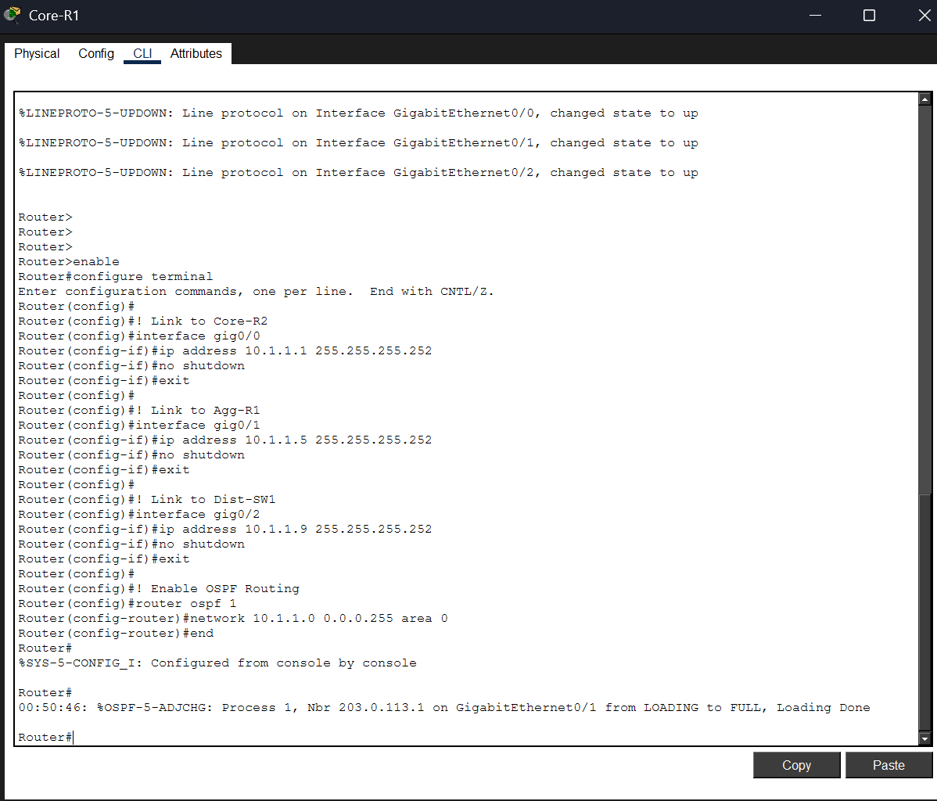
Figure 2: Core-R1 - Gig0/0 (10.1.1.1) to Core-R2, Gig0/1 (10.1.1.5) to Agg-R1, Gig0/2 (10.1.1.9) to Dist-SW1. OSPF adjacency confirmed with neighbour 203.0.113.1.

3.4 Core-R2 Configuration
Core-R2 provides the second backbone path and connects directly to Dist-SW2, ensuring the right access block has a resilient routed uplink through the Core Layer.

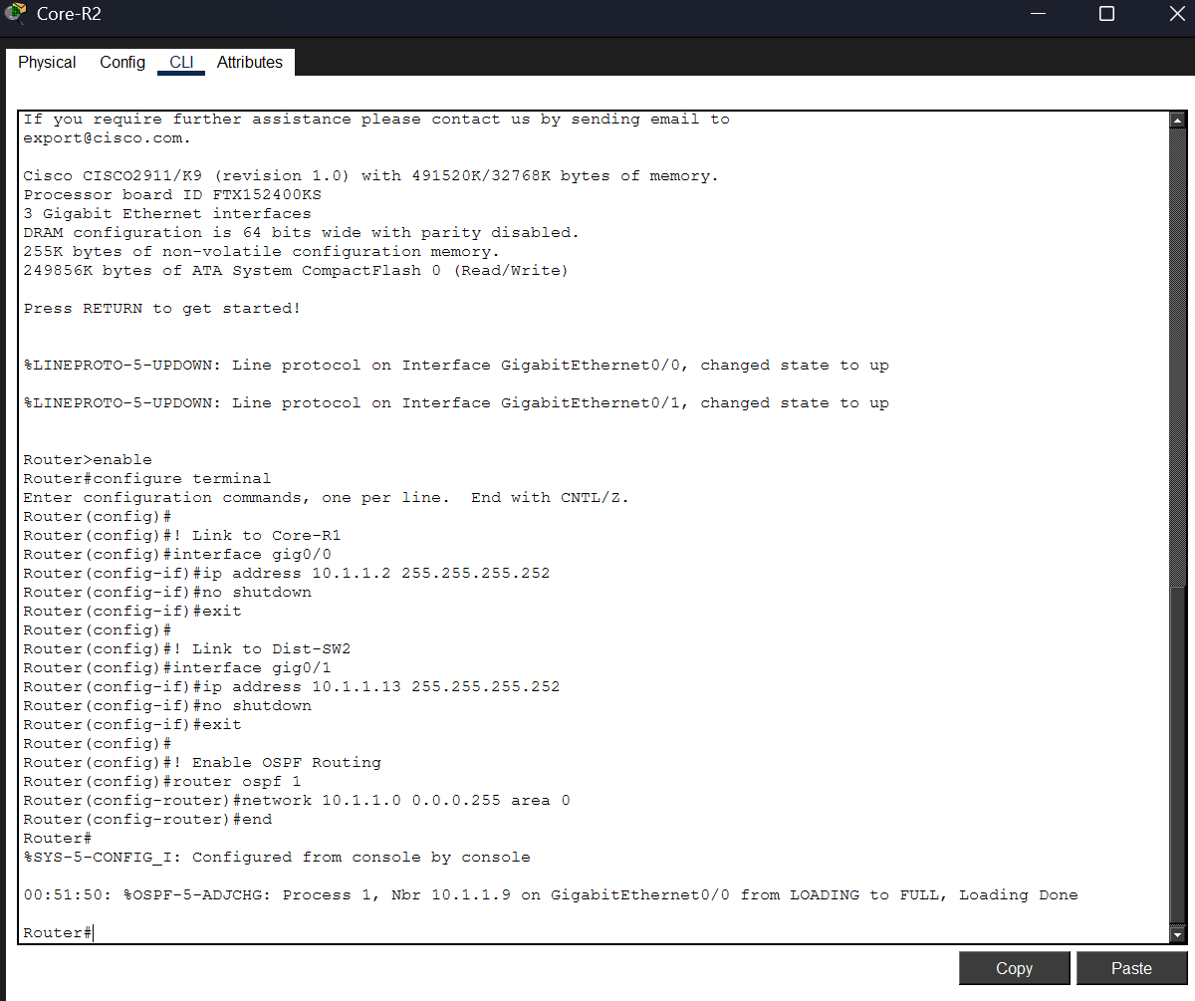
Figure 3: Core-R2 - Gig0/0 (10.1.1.2) to Core-R1, Gig0/1 (10.1.1.13) to Dist-SW2. OSPF adjacency confirmed with neighbour 10.1.1.9.

3.5 Agg-R1 Configuration (External Gateway)
Agg-R1 is the boundary router of the Aggregation Block. Its Gig0/0 interface connects inward to Core-R1 using the internal 10.1.1.0/8 space, while its Gig0/1 interface is assigned the public IP 203.0.113.1/24 and connects to Cloud-PT to emulate an external WAN boundary. Both networks are advertised into OSPF, making the external prefix reachable by all internal devices.

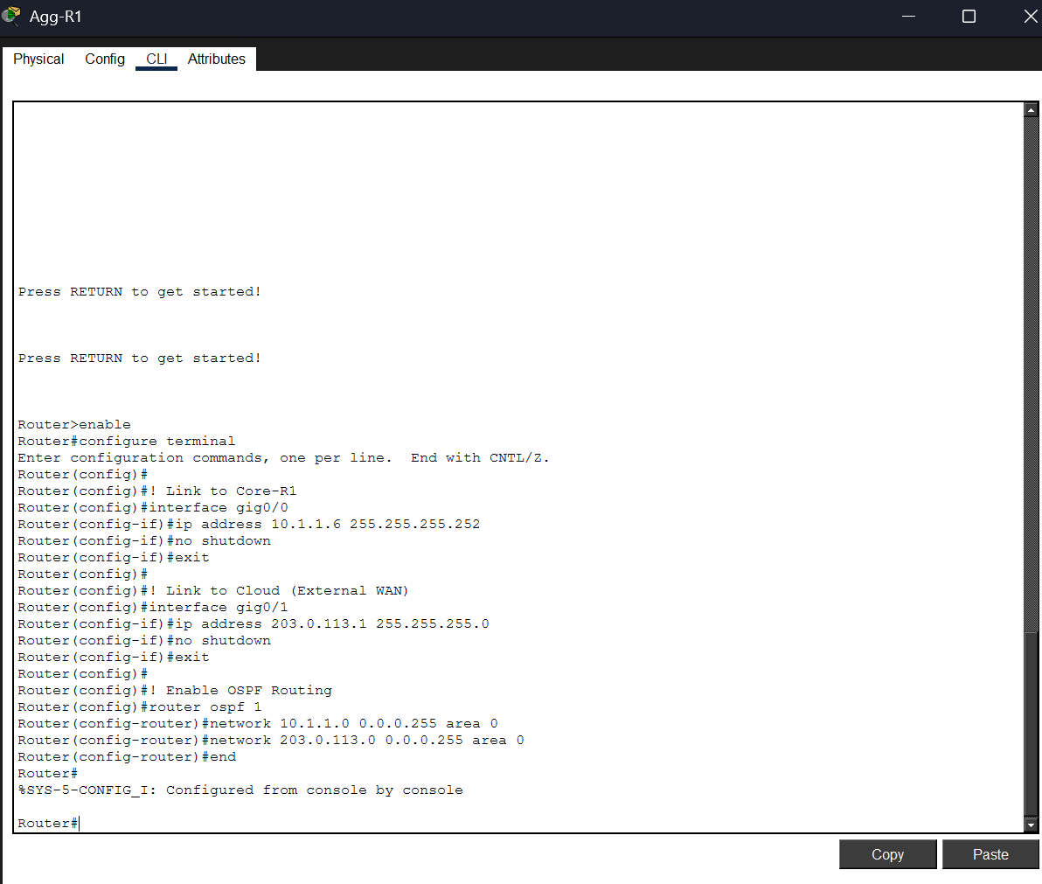
Figure 4: Agg-R1 - Gig0/0 (10.1.1.6) to Core-R1; Gig0/1 (203.0.113.1) to Cloud-PT (WAN boundary). Both networks in OSPF Area 0.

3.6 Dist-SW1 Configuration (Left Access Block)
Dist-SW1 is a Layer 3 Cisco 3560-24PS switch. The ip routing command enables Layer 3 forwarding. Its Fa0/1 interface was converted to a routed port (no switchport) with address 10.1.1.10/30, pointing to Core-R1. A VLAN 1 SVI was created with IP 192.168.10.1/24, which serves as the default gateway for all devices in the left Access Block. Both subnets are advertised into OSPF.

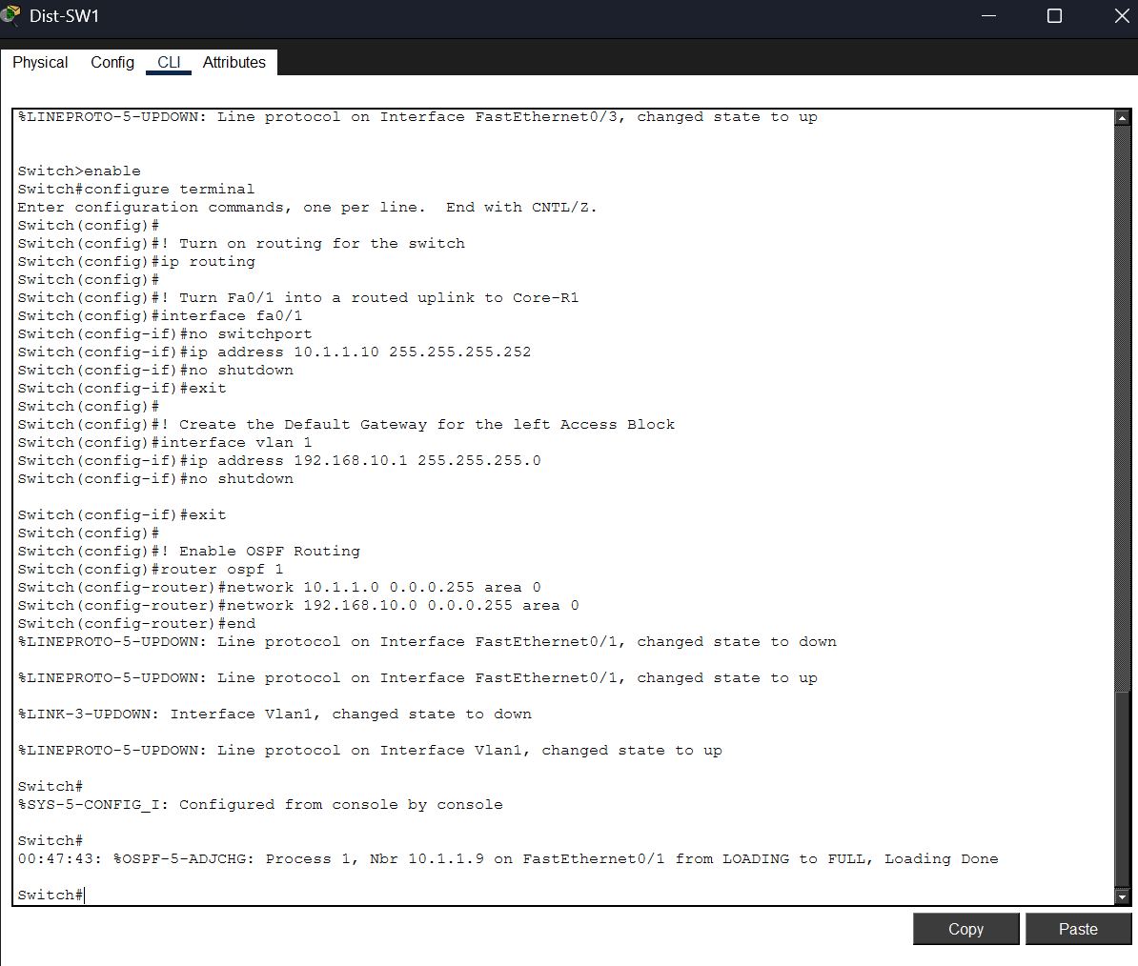
Figure 5: Dist-SW1 - Fa0/1 routed port (10.1.1.10) to Core-R1; VLAN 1 SVI (192.168.10.1) as access-block gateway. OSPF adjacency confirmed.

3.7 Dist-SW2 Configuration (Right Access Block)
Dist-SW2 mirrors the configuration of Dist-SW1 but serves the right Access Block. Its routed uplink to Core-R2 uses 10.1.1.14/30, and its VLAN 1 SVI (192.168.20.1/24) acts as the default gateway for all devices in the right access segment.

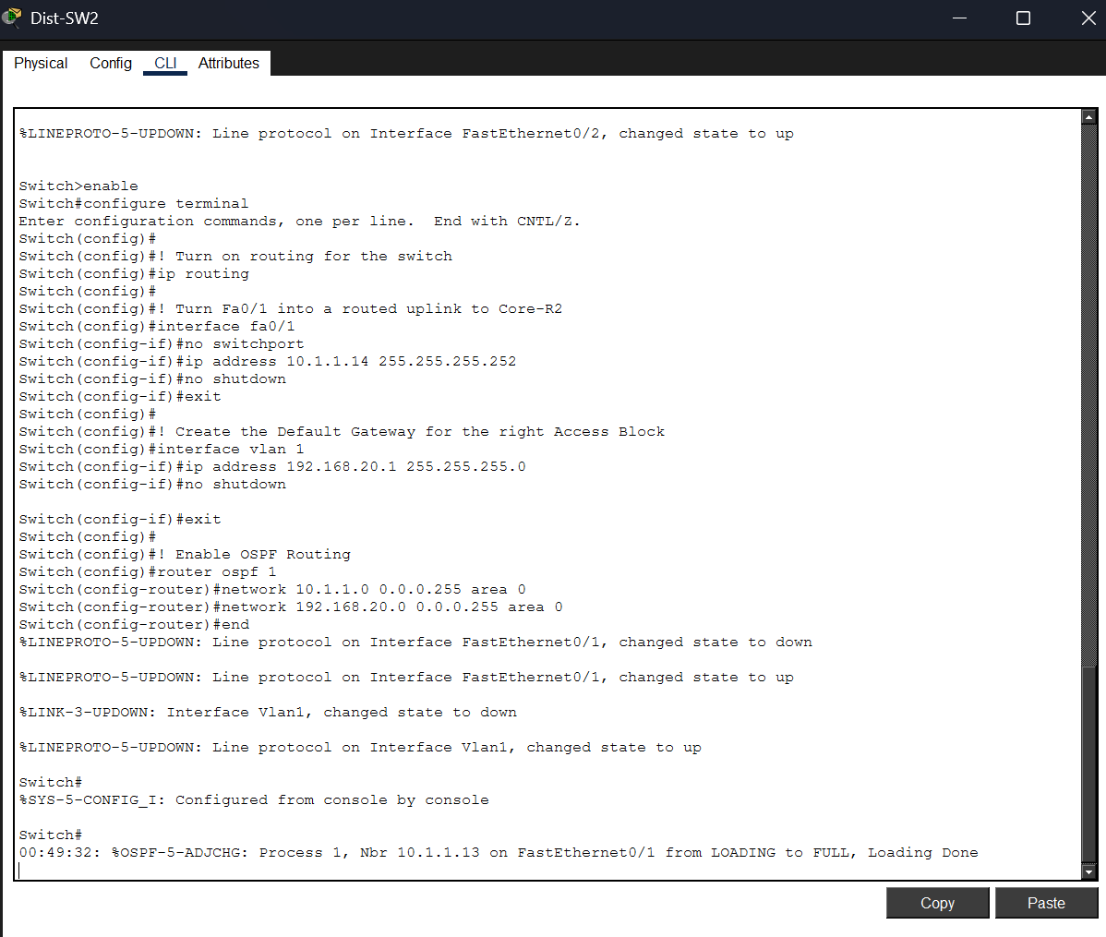
Figure 6: Dist-SW2 - Fa0/1 routed port (10.1.1.14) to Core-R2; VLAN 1 SVI (192.168.20.1) as access-block gateway. OSPF adjacency confirmed.

3.8 Wireless Access Point Configuration
To manage wireless endpoints within the Access Block, each Access Point was configured with a unique SSID to logically segment wireless traffic and associate devices to the correct subnet. Authentication was set to open (disabled) for this simulation environment.

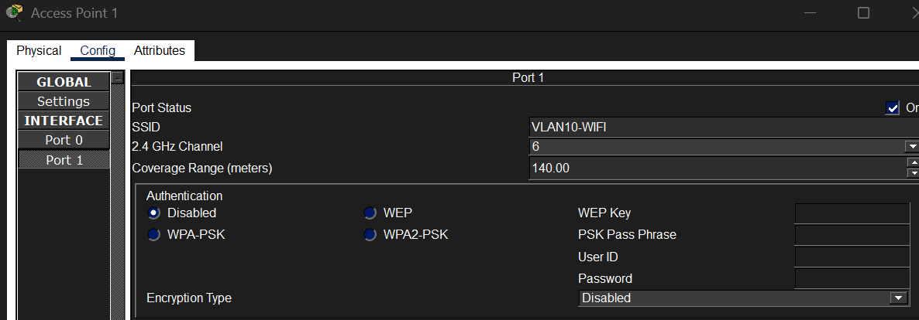
Figure 7: AP1 - SSID: VLAN10-WIFI, Ch. 6, 140m range.
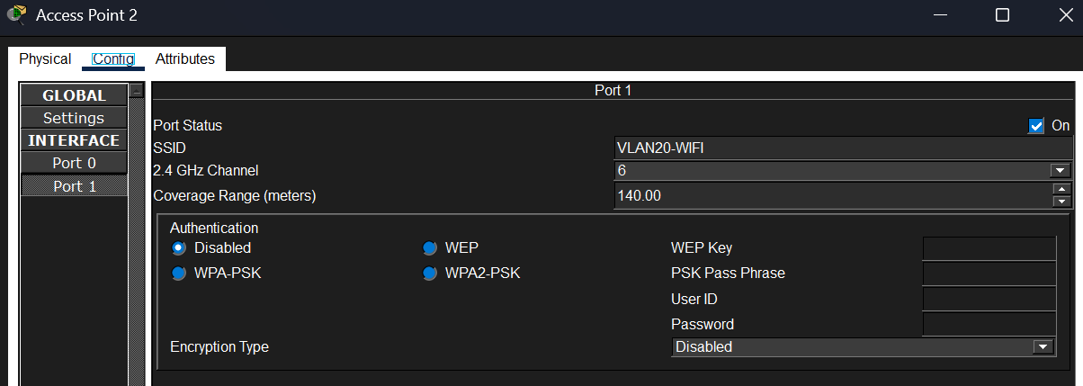
Figure 8: AP2 - SSID: VLAN20-WIFI, Ch. 6, 140m range.
Access Point | SSID | Channel | Connected Wireless Devices
Access Point 1 | VLAN10-WIFI | 6 (2.4 GHz) | Smartphone0
Access Point 2 | VLAN20-WIFI | 6 (2.4 GHz) | Laptop2

4. IP Addressing Scheme
The lab uses two distinct IP address spaces: the internal routing backbone (10.1.1.0/8, point-to-point /30 links) and the end-user access subnets (192.168.x.0/24). The external WAN simulation uses public block 203.0.113.0/24.

Infrastructure / Backbone Links (Point-to-Point /30)
Link | Device A Address | Device B Address | Subnet
Core-R1 (Gig0/0) ↔ Core-R2 (Gig0/0) | 10.1.1.1 /30 | 10.1.1.2 /30 | 10.1.1.0/30
Core-R1 (Gig0/1) ↔ Agg-R1 (Gig0/0) | 10.1.1.5 /30 | 10.1.1.6 /30 | 10.1.1.4/30
Core-R1 (Gig0/2) ↔ Dist-SW1 (Fa0/1) | 10.1.1.9 /30 | 10.1.1.10 /30 | 10.1.1.8/30
Core-R2 (Gig0/1) ↔ Dist-SW2 (Fa0/1) | 10.1.1.13 /30 | 10.1.1.14 /30 | 10.1.1.12/30
Agg-R1 (Gig0/1) ↔ Cloud-PT (WAN) | 203.0.113.1 /24 | N/A | 203.0.113.0/24

End-Device / Access Block Addressing
Device | Access Switch | IPv4 Address | Default Gateway | Connection
PC0 | Access-SW1 | 192.168.10.10 | 192.168.10.1 (Dist-SW1) | Wired - Fa0/2
Laptop0 | Access-SW1 | 192.168.10.11 | 192.168.10.1 (Dist-SW1) | Wired - Fa0/3
Smartphone0 | AP1 (SW2) | 192.168.10.14 | 192.168.10.1 (Dist-SW1) | Wireless - VLAN10-WIFI
PC1 | Access-SW2 | 192.168.10.12 | 192.168.10.1 (Dist-SW1) | Wired - Fa0/2
Laptop1 | Access-SW2 | 192.168.10.13 | 192.168.10.1 (Dist-SW1) | Wired - Fa0/3
Laptop2 | AP2 (SW3) | 192.168.20.10 | 192.168.20.1 (Dist-SW2) | Wireless - VLAN20-WIFI

5. Connectivity Validation
To verify the integrity of the OSPF routing configuration and the full physical topology, an ICMP Echo Request (Ping) was initiated from a wireless edge device - Smartphone0 at the far end of the Access Block - to the external Aggregation gateway interface at 203.0.113.1. This test requires successful packet forwarding across all four network tiers.

Traffic Path | Hop Details
Hop 1 - Access | Smartphone0 (192.168.10.14) → Access Point 1 → Access-SW2 (Layer 2 forwarding)
Hop 2 - Distribution | Access-SW2 → Dist-SW1 (192.168.10.1 SVI gateway, inter-VLAN routing)
Hop 3 - Core | Dist-SW1 → Core-R1 (10.1.1.9 routed link, OSPF-learned route to 203.0.113.0/24)
Hop 4 - Core | Core-R1 → Agg-R1 (10.1.1.5 link, OSPF next-hop selection)
Hop 5 - Aggregation | Agg-R1 → Cloud-PT on 203.0.113.1 (external WAN interface - destination reached)

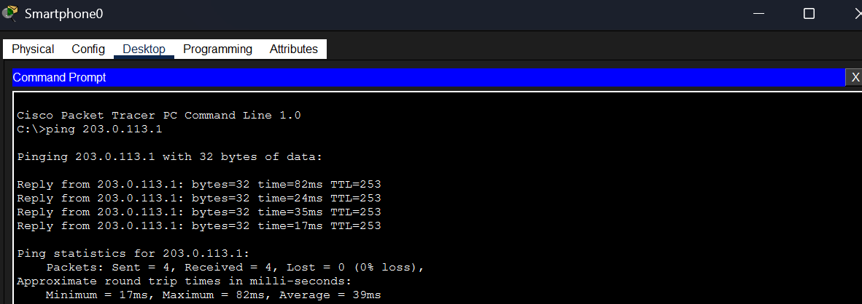
Figure 9: Smartphone0 → 203.0.113.1 4 packets sent, 4 received, 0% loss. Average RTT: 39ms. TTL=253 confirms 3-hop path through the enterprise tiers.

Source | Destination | Result | TTL / RTT
Smartphone0 - 192.168.10.14 | 203.0.113.1 (Agg-R1 WAN) | 4/4 - 0% Loss | TTL=253 / Avg 39ms

6. Conclusion
Week 5 successfully demonstrated the design, configuration, and validation of a fully functional enterprise-level network architecture in Cisco Packet Tracer. The topology evolved from the three-tier model of Week 4 into a four-block enterprise design, introducing an explicit Aggregation Block to handle external WAN/Cloud boundaries and distributing routing intelligence across the Core, Aggregation, and Distribution tiers.

✓ | Achievement
✓ | A four-block enterprise architecture (Core, Aggregation, Distribution, Access) was successfully designed and implemented in Cisco Packet Tracer.
✓ | OSPF Area 0 was deployed on all five routing devices, eliminating static routes and enabling fully dynamic, self-healing routing table propagation.
✓ | The Core Block (Core-R1, Core-R2) provides a redundant backbone ensuring no single point of failure between the Distribution and Aggregation tiers.
✓ | The Aggregation Block (Agg-R1 + Cloud-PT) correctly models the enterprise-to-WAN boundary, hosting a public IP subnet (203.0.113.0/24) reachable by all internal endpoints.
✓ | The Distribution Block (Dist-SW1, Dist-SW2) converts Layer 3 Cisco 3560 switches into inter-VLAN routers using SVI gateways, bridging the Layer 2 access edge and the Layer 3 core.
✓ | Wireless endpoints (Smartphone0, Laptop2) were segmented using dedicated SSIDs (VLAN10-WIFI, VLAN20-WIFI) and successfully associated via their respective Access Points.
✓ | End-to-end connectivity was validated: Smartphone0 pinged the external gateway 203.0.113.1 with 4/4 packet success, 0% loss, and an average RTT of 39ms - confirming all four tiers are fully operational.

This Week 5 network represents a production-grade enterprise architecture. The four-block modular design ensures that each tier can scale, be troubleshot, or be upgraded independently - a fundamental property of real-world enterprise networks. The successful OSPF convergence across all devices, culminating in cross-tier reachability from a wireless smartphone at the network edge to a simulated WAN gateway, validates the complete operational integrity of the design.

